**MP#1. Make sense of problems and persevere in solving them**

**Grade 5:** 5.NF.7.c (from EngageNY 2014)

Deb has a board that measures 5 feet in length. How many  foot-long pieces can Deb cut from the board?

A. 1 B. 9 C. 10 D. 20



**Key: D  Measured CCLS: 5.NF.7.c**

**Commentary:** This question measures 5.NF.7.c by asking the student to solve real-world problems involving division of whole numbers by unit fractions.

**Grade 8:** from EngageNY 2014 exam

The combined volume of all the tanks at an aquarium is 1.25 × 106 gallons. The aquarium plans to install a new dolphin tank with a volume of 250,000 gallons. What will be the total volume of all of the tanks at the aquarium after the new dolphin tank is installed?

**A** 1.5×105 **B** 3.75 × 105 **C** 1.5×106 **D** 3.75×106

**Key: C Measured CCLS: 8.EE.4**

**Commentary:** This question measures 8.EE.4 because it assesses the student’s ability to perform operations with numbers expressed in scientific notation in a problem where both decimal and scientific notation are used.

**MP#3 Construct viable arguments and critique the reasoning of others.**

**Grade 5:** (from NY Regents June 2010 book 2 example 30)

<http://www.nysedregents.org/Grade5/Mathematics/20100505book2.pdf>

Alice draws a triangle and measures two of the angles with a protractor. The angle measures are 65˚ and 45˚.

Cal says the measure of the third angle is 60˚. On the lines below, explain why Cal’s answer is incorrect.

Be sure to identify the correct measure of the third angle in Alice’s triangle in your explanation.

|  |
| --- |
|  |
|  |
|  |
|  |
|  |

**Grade 8:** (from EngageNY 2014 test page 59)

**Measured CCLS: 8.F.3**

**Commentary:** This question measures 8.F.3 because it assesses a student’s ability to recognize and explain if a function is linear by showing that it cannot be defined by an equation in the form *y* = *mx* + *b* or by determining if its graph is a straight line.

Does the equation below define a linear function? , when 

***Explain how you got your answer.***

***Answer***

|  |
| --- |
|  |
|  |
|  |
|  |
|  |

**MP#4 Model with Mathematics**

**Grade 8:** (from EngageNY 2013 test)

The population growth of two towns over a period of five years is represented by the system of equations below, both algebraically and graphically.

*y* = *x +* 6

*y* = 2*x +* 2

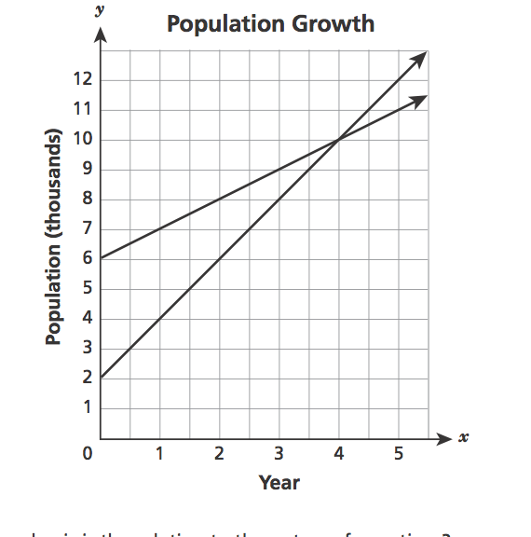

Which ordered pair is the solution to the system of equations?

**A** (2,6) **B** (4, 10) **C** (6,2) **D** (10, 4)

**Key: B  Measured CCLS: 8.EE.8a**

**Commentary:** This question measures 8.EE.8a because it assesses the student’s ability to understand that solutions to a system of two linear equations in two variables correspond to points of intersection of their graphs, because points of intersection indicate values that satisfy both equations simultaneously.

**MP#6 Attend to Precision**

**Grade 5:** (from EngageNY test 2014 page 28)

A racecar driver completed three laps in the times shown below.

• 39.28 seconds

• 38.9 seconds

• 37.83 seconds

What was the total time, in seconds, it took for the driver to complete the three laps?

***Show your work.***

|  |
| --- |
|  |

**Measured CCLS: 5.NBT.7 Commentary:** This question measures 5.NBT.7 because it assesses a student’s ability to add decimals to hundredths.

**MP#7 Look for and Make Use of Structure**

**Grade 8:** (from Engage NY 2014 test)

The four tables below show relationships in which the *x* values represent inputs and the *y* values represent the corresponding outputs.

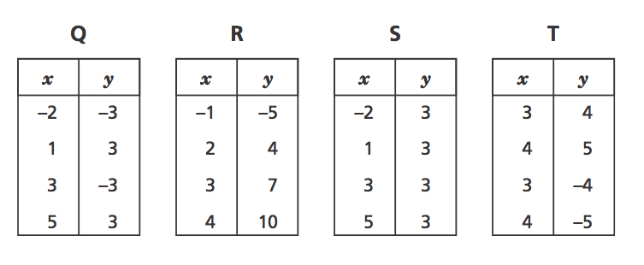

Which table represents a relationship that is **not** a function?

**A.** Q **B.** R **C.** S **D.** T

**Key: D  Measured CCLS: 8.F.1**

**Commentary:** This question measures 8.F.1 because it involves assessing the student’s understanding that a function is a rule that assigns to each input exactly one output.

**Grade 8:** (from EngageNY test 2014 page 72)

A box contains 9 identical glass spheres that are used to make snow globes. The spheres are tightly packed, as shown below.

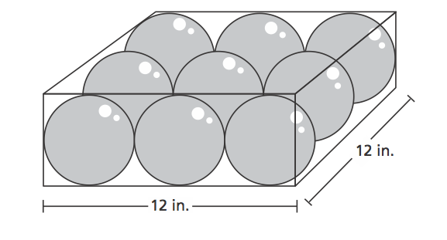

What is the total volume, in cubic inches, of all 9 spheres? Round your answer to the nearest tenth of a cubic inch.

Volume of sphere = 

***Show your work.***

|  |
| --- |
|  |

**MP#8 Look for and express regularity in repeated reasoning.**

**Grade 5:** (from NY Regents example 29)

<http://www.nysedregents.org/Grade5/Mathematics/20100505book2.pdf>

Roberto used pairs of blocks to create the repeating pattern below.

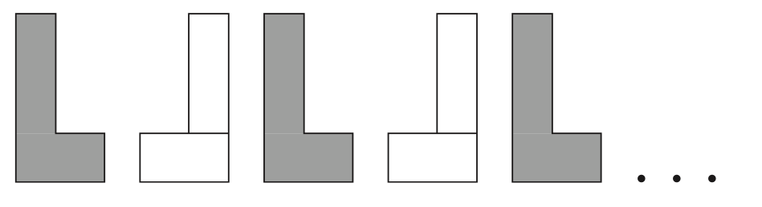

***Part A***

In the space below, draw the next shape that will continue this repeating pattern.

***Part B***

On the lines below, explain the rule for the pattern.

|  |
| --- |
|  |
|  |
|  |
|  |
|  |

**Grade 8:** (from Barron’s Grade 8 NJ Math CCSS/PARCC 2015 edition, author J. Brendel Test 1 example 14, standard: 8.EE.1)

Answer the following questions based on the expression 

Check √ Yes if the statement is true; check √ No if it is not true.

A. Simplified, this is equivalent to  ___ Yes ___ No

B. This expression is equivalent to  ___ Yes ___No

C. The following is an equivalent expression: ___ Yes ___No

D. An equivalent expression is  ___Yes ___No

E. Another way to write this is -4. ___Yes ___No