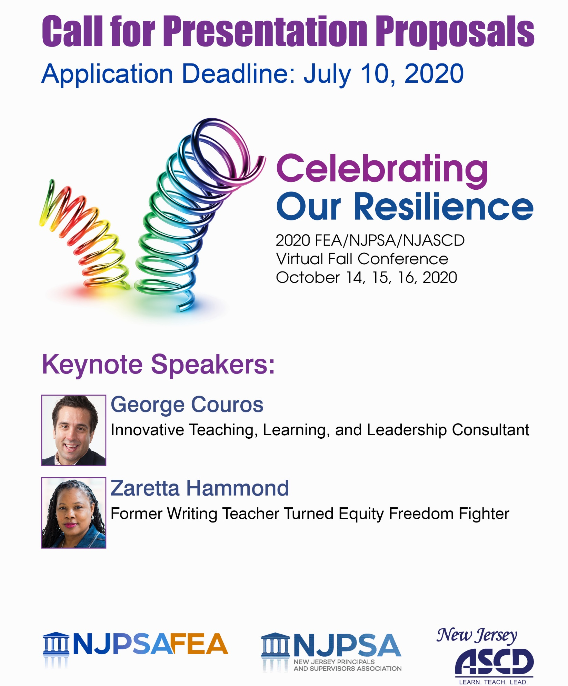

Presentation Format

We invite you to present to your colleagues at the 2020 Fall Conference, “Celebrating Our Resilience”

Time slots for each session will be 60 minutes on Wednesday, October 14, Thursday, October 15, or Friday, October 16. Presenters who are accepted to present agree to:

- Present your session using Zoom;
- Engage participants in collaborative discussions and activities that will involve them in learning new strategies and consider options for implementation in their own district;
- Provide links to appropriate handouts for the session;
- Eliminate all sales messages or marketing of services or products.

Lead presenters* will be given a 20% conference registration discount (maximum of two presenters per session can receive the discount).

There are 12 workshop strands or themes that will be included in the sessions. Please review these and indicate which strand most closely aligns to your application submission.

Strand Topics:
Diversity, Equity, Inclusion, and Access
Continuity of Learning and Student Engagement across Learning Environments
Parental Engagement in a Virtual Environment
Future of Learning/Technology Integration
Arts Integration
Climate, Culture, and Social Emotional Learning
Culturally Responsive Practices
Curriculum, Instruction, and Assessment
Leadership: Shared Leadership, Teacher Leadership, Leadership Development
Learning Communities
Mental Health Issues (students, staff, and community)
Struggling Learners

2020 APPLICATION

Please complete the application. Include the title of the presentation and a description. List the presenter’s name and contact information. Up to two lead presenters will get a 20% registration discount.* Additional presenters will pay the regular cost to attend.

Presentation Title

*Lead Presenter’s Name | Title/Position
School/District or Organization
Home Address
City | State | Zip Code
Daytime Phone | Cell Phone
Work Email Address | Home Email Address
Twitter Handle:

*Lead Presenter’s Name | Title/Position
School/District or Organization
Home Address
City | State | Zip Code
Daytime Phone | Cell Phone
Work Email Address | Home Email Address
Twitter Handle:

Additional Presenter’s Name | Title/Position
School/District or Organization
Cell Phone
Work Email Address | Home Email Address
Twitter Handle:

Additional Presenter’s Name | Title/Position
School/District or Organization
Cell Phone
Work Email Address | Home Email Address
Twitter Handle:

Deadline for application submission is July 10, 2020.

Please provide a description of your project. (Limit to one page and a half.)

- Presentation Title

- Program Description/Abstract (Write a 75-word summary describing the workshop. This summary will be used for the conference brochure.)
- Participant Outcomes (Identify the learning objectives for participants. What knowledge and skills will leaders gain as a result of the workshop?)
- Session Processes (Describe the content and specific activities that will be used to engage your intended audience keeping in mind that a virtual platform will be utilized.)

- Please indicate with a check mark, which strand your presentation relates to and which day you are available to do the workshop:

Strands | Wed. | Thur. | Fri.
Diversity, Equity, Inclusion, and Access
Continuity of Learning and Student Engagement across Learning Environments
Parental Engagement in a Virtual Environment
Future of Learning/Technology Integration
Arts Integration
Climate, Culture, and Social Emotional Learning
Culturally Responsive Practices
Curriculum, Instruction, and Assessment
Leadership: Shared Leadership, Teacher Leadership, Leadership Development
Learning Communities
Mental Health Issues (students, staff, and community)
Struggling Learners

If you are chosen as a lead presenter, a 20% adjustment will be made to your registration.

For consideration, complete the application and email it as a Word document to conferenceproposals@njpsa.org.

Questions? Contact Christy Stoehr at cstoehr@njpsa.org or (609) 860-1200 x 113.

Deadline for application submission is July 10, 2020.

